Lessons We Fail to Teach in School
AJ Juliani
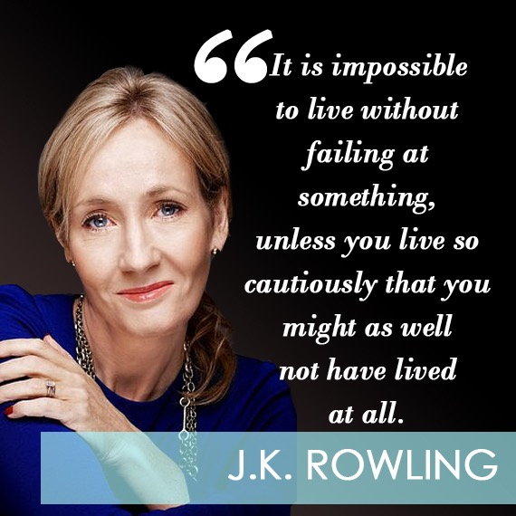
Joanne’s mother had died a few years earlier, and now she was a single parent (recently divorced) with no job, living off welfare benefits so she could provide for her young daughter. Worst yet, she was battling extreme depression and on the verge of suicide.
But, she had an idea…and belief that it was important. A few years later and still on welfare, Joanne submitted her manuscript to 12 publishers. They all rejected it. The 13th publisher took a look and gave her a chance. Joanne (J.K.) Rowling would have her first book published, Harry Potter and the Sorcerer’s Stone…
Rich struggled in school as a teenager battling with dyslexia. His grades were awful and one teacher told him he would either wind up in jail or become a millionaire. He didn’t like the way he was being taught in school so he decided to leave and make his own magazine at age 16 with no money to his name.
He landed $8000 in advertisements for the first issue (and this was in 1966) in what would be his first business venture. Richard Branson would go on to sell records, fly planes, and create over 200 other business ideas on his way to becoming a billionaire…

Do You Believe in Yourself?
Most people I talk to seem to act like J.K. Rowling and Richard Branson are outliers. They made it big under circumstances that would crush most of us. Yet, there has to be something we can learn from their paths to success.
In her 2008 Harvard Commencement Address, Rowling talks about succeeding while seeing herself as a complete failure. Because she had failed the only thing left was to do work that truly mattered to her:
Failure meant a stripping away of the inessential. I stopped pretending to myself that I was anything other than what I was, and began to direct all my energy to finishing the only work that mattered to me. Had I really succeeded at anything else, I might never have found the determination to succeed in the one area where I truly belonged. I was set free, because my greatest fear had been realized, and I was still alive, and I still had a daughter whom I adored, and I had an old typewriter, and a big idea. And so rock bottom became a solid foundation on which I rebuilt my life.
And Branson says something similar. He succeeded at his magazine business because he cared about being an editor and was driven by passion:
Ideally, since 80 percent of your life is spent working, you should start a business around something that is a passion of yours. If you’re into kite-surfing and you want to become an entrepreneur, do it with kite-surfing.
Look, if you can indulge in your passion, life will be far more interesting than if you’re just working. You’ll work harder at it, and you’ll know more about it. But first you must go out and educate yourself on whatever it is that you’ve decided to do – know more about kite-surfing than anyone else. That’s where the work comes in. But if you’re doing things you’re passionate about, that will come naturally.
Branson and Rowling both believed in their ideas, but more importantly, they believed they could accomplish something great in the face of adversity. Maybe no one else in the world would have gave them a fighting chance…but they believed it would happen.

The Lessons We Fail to Teach in School
It seems like “failure” has become a buzzword of sorts in education. Some love to use it. Others despise it. We treat it as a bad word, as if “failing” is something to be ashamed about. When in fact, what makes someone great (and successful) is coming back from adversity and learning from their trials (also sometimes known as failings).
I’d love to replace those “student of the month” boards with “epic failure/trial” boards. Let’s celebrate students and staff that are taking risks, trying something new, and coming back with resilience again and again.
Above all else, we want our students to be in school believing in themselves. So when they leave our schools they believe they can accomplish anything. As a teacher and school leader do you believe that about yourself?
As a teacher, I had seven lessons to give my students before they left school. These are lessons that I’ve had to learn in order to believe in myself. They are the lessons that J.K. Rowling, Richard Branson, and thousands of other successful people live by every day…
1. Scratch Your Own Itch
Stop trying to “find” your passion. Do what you like and enjoy. And experience new things on a regular basis. Chances are you are wasting your time if you spend it “trying to find your passion.” We all have likes and dislikes. We have interests and things we never want to do. Do more of what you like and what makes you happy. But don’t forget to experience the world around you. Who knows when inspiration will strike, but when it does be ready to act on it.
2. You are in the driver seat. So buckle up and drive.
Steve Jobs said, “Everything around you that you call life was made up by people that were no smarter than you, and you can change it, you can influence it, you can build your own things that other people can use.” Simply put, regardless of your circumstances, you are in charge of where your life goes. The reason we love “rags-to-riches” stories is that they can happen, and do happen, every day.
3. You need to stop distracting yourself and start inspiring yourself.
What are you accomplishing by watching the TV, reading your social feeds, and sending pictures back and forth? If the TV and your phone work as distractions then try to limit wasting your time. If you are watching, reading, and listening to things that inspire you…then you are on the right track. Surround yourself with people that inspire you, and you’ll do amazing work.
4. Big thinking actually does work.
If you want to do something big you have to think big. Too many times we are told that are dreams are just that…dreams. But the only way a dream becomes a reality is by truly believing you can make it happen. As said in The Pursuit of Happiness: “You got a dream… You gotta protect it. People can’t do somethin’ themselves, they wanna tell you that you can’t do it. If you want somethin’, go get it. Period.”
5. Motion creates motion…and it creates ideas.
When you start moving towards a goal it drives you forward even further. This is why just the act of “doing something” can help people get into a better mindset. Motion also gets the mind moving and creates new ideas. Moral of the story: Get out and do something, even if it is small. Then let the snowball effect take place!
6. You better start trying new things and challenging yourself ASAP!
How many times can you fail? The answer is none if you don’t try anything new or challenging. How many times can you get back up after you don’t succeed? But the most important question to ask yourself is: How much can you learn from not succeeding the first time? Start “failing” today and change the way you perceive this word. See it as an opportunity for growth and learning. See it as a way to test new ideas and improve understanding. See it is as a necessary step to success and not the “end” of anything.
7. Live for others not yourself.
What can you do to help people? What problems do you have that others might have as well? What can you contribute to this world… Living for others is simple. It doesn’t mean letting go of your goals and aspirations, instead it’s about merging those goals with the needs of others. Do that.
I’ll leave you with one final quote from J.K. Rowling:
It is impossible to live without failing at something, unless you live so cautiously that you might has well not have lived at all, in which case you have failed by default.
Go on and try something new. Scratch your itch and see what happens. But above all else, keep believing in yourself.

